
PAWAN KUMAR SINGH
2501730252

LED Circuit
- Things needed for project:-
- An Arduino Uno board
- 4-6 LEDs (e.g., red, green, blue)
- 4-6 Resistors (220 Ohm is a common value for LEDs with 5V Arduino)
- A breadboard (optional, but makes wiring easier)
Here's a diagram illustrating how to connect one LED, and you'll repeat this for each additional LED.
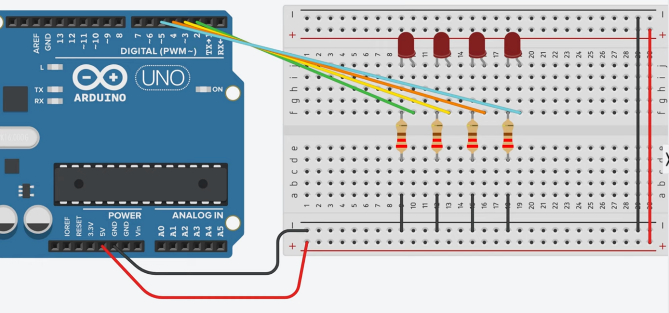

- LED Anode (Longer Leg): Connect to one end of a resistor.
- Resistor: The other end of the resistor connects to an Arduino digital pin (e.g., D2, D3, D4, D5).
- LED Cathode (Shorter Leg): Connect to the Arduino's GND (Ground) pin. You can connect all LED cathodes to the same GND pin, either directly or via the breadboard's ground rail.
2. Programming (Arduino Code)
You'll write code that controls these pins. Here's a basic structure and then specific patterns.
// Simple LED Blinking Code
// Controls 4 LEDs on pins D2 to D5.
// Patterns: 1) Sequential, 2) Alternating, 3) Running light.

#define NUM_LEDS 6 // Number of LEDs
int ledPins[] = {2, 3, 4, 5}; // LED pins

void setup() {
for (int i = 0; i < NUM_LEDS; i++) {
pinMode(ledPins[i], OUTPUT); // Set pins as output
}
}

void loop() {
// Pattern 1: Sequential blink (one by one)
for (int i = 0; i < NUM_LEDS; i++) {
digitalWrite(ledPins[i], HIGH); // On
delay(500); // Wait
digitalWrite(ledPins[i], LOW); // Off
}
delay(1000); // Pause

// Pattern 2: Alternating (even vs odd, 2 times)
for (int c = 0; c < 2; c++) {
// Even LEDs on
for (int i = 0; i < NUM_LEDS; i += 2) {
digitalWrite(ledPins[i], HIGH);
}
delay(500);
// All off
for (int i = 0; i < NUM_LEDS; i++) {
digitalWrite(ledPins[i], LOW);
}
// Odd LEDs on
for (int i = 1; i < NUM_LEDS; i += 2) {
digitalWrite(ledPins[i], HIGH);
}
delay(500);
// All off
for (int i = 0; i < NUM_LEDS; i++) {
digitalWrite(ledPins[i], LOW);
}
}
delay(1000); // Pause

// Pattern 3: Custom running light (wave)
for (int i = 0; i < NUM_LEDS; i++) {
digitalWrite(ledPins[i], HIGH);
delay(300);
}
for (int i = NUM_LEDS - 1; i >= 0; i--) {
digitalWrite(ledPins[i], LOW);
delay(300);
}
delay(1000); // Pause before repeat
}
Code Explanation and Comments:
- const int ledPins[] = {2, 3, 4, 5};: This line creates an array to store the digital pin numbers you're using for your LEDs. This makes it much easier to loop through them.
- const int numLeds = sizeof(ledPins) / sizeof(ledPins[0]);: Calculates the number of LEDs in your array automatically.
- void setup(): This function runs once when the Arduino starts.
  - pinMode(ledPins[i], OUTPUT);: Sets each of the specified pins as an OUTPUT pin, meaning the Arduino will send voltage signals out from these pins.
- void loop(): This function runs repeatedly after setup() finishes.
  - It calls the different pattern functions you've defined (sequentialBlink, alternateBlink, customPatternRunningLights, allOnOffPattern).
  - delay(1000);: Pauses the program for 1000 milliseconds (1 second) between each pattern, so you can clearly see them.
- Pattern Functions (sequentialBlink, alternateBlink, etc.):
  - digitalWrite(pin, HIGH);: Sends a HIGH (5V) signal to the specified pin, turning the connected LED ON.
  - digitalWrite(pin, LOW);: Sends a LOW (0V) signal to the specified pin, turning the connected LED OFF.
  - delay(milliseconds);: Pauses the execution for the given number of milliseconds. This is crucial for controlling the timing of your blinks.
  - i % 2 == 0: This is a common programming trick to check if a number (i in this case) is even. The modulo operator (%) gives the remainder of a division. If the remainder when divided by 2 is 0, the number is even.

